Tai Chi Daily Practice: A neuroscientist’s discoveries

Lucy Brown neuroscientist

I’m reading a book called, “How to Change Your Mind” by Michael Pollan. It’s fascinating. It tells the story of how hallucinogens have been used from prehistory to now, and their current usefulness. For one thing, many people who have terminal illnesses lose their fear of death when they take a drug called Psilocybine, a naturally-occurring psychedelic derived from a mushroom. People who take it say there is a mysterious change in attitude about oneself. It seems the drugs act on brain areas that code the sense of self, such as autobiographical memories we have and the feeling of our bodies, our somatosensory/bodily self. I couldn’t help thinking as I read the book that there is another way to change your mind, and body, and ultimately the sense of self. It is daily practice of Tai Chi.
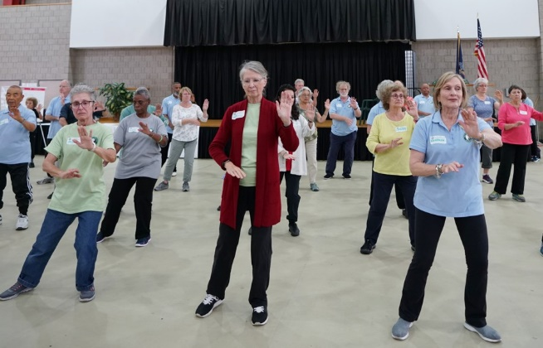
I discovered Tai Chi 2 years ago at a local Senior Center. I went to Tai Chi for Arthritis classes twice a week for over a year. I was hooked during the first class by the grace of the movements and how open and energized I felt after a lesson. The place and people there at the class were probably important, just as context is important for the experience people have when they take hallucinogens. Many of the people at the class were long-term friends and the room was familiar.

For each class, I followed the teacher. I often had to look over my shoulder to see what she was doing. Only a few of the movements were internalized for me so I could show them to a friend outside of class. Those internalized, remembered movements were mostly from the warm-ups, like the spine stretches. But it didn’t matter. During the class it was delightful to move with a group and feel that I was learning. Occasionally I got a sense of “flow.” In retrospect I was getting a lovely, tiny benefit compared to what was to come. Following the teacher was helpful and fun, but the addition of the daily habit turned out to be wildly beneficial for me.

After nearly a year of classes, I decided to teach Tai Chi for Arthritis. I soon realized such a goal requires daily practice to learn the sequences well enough to teach. To my astonishment, the daily practice changed my body and mind. I became stronger and calmer. After two months of daily practice I understood the strength that is possible in my knees and ankles in an entirely new way. Also, some of the knee bends and half-steps had become automatic, influencing how I emptied the dishwasher. I moved around my kitchen doing my chores in a different way. Some of the calm had become automatic, too. Waiting at the train station or on line at the supermarket I didn’t fret but found myself “exercising” by practicing the posture of infinity, one of my favorites. The daily habit had changed my mind and movements in an unexpected way.

The rewards of the new feelings made the daily practice a habit—almost an addiction!

As a neuroscientist I thought about the possible brain impact, and the neural systems being used. One nugget of information to think about for daily practice is this-- What parts of the brain are affected by Alzheimer’s disease? And could use as much “exercise” as possible? Surprisingly, one of them processes the sense we have of our bodies, like the areas affected by psychedelics. It is a large area of neatly layered cells that at the simplest level tell us where our bodies are in space. At the more complex level the area forms our sense of a separate person from others. At the most complex level, it processes empathy and the ability to imagine the physical feelings of others. It is involved in establishing our memories, because all memories involve the sense of where we are in space. It is called the parietal cortex. The bombshell is that this area is very active as you do Tai Chi, in an especially strong way, unique from everyday movements. It’s that grace of the slow motion, done mindfully, upright posture, opening of the joints, breathing and mental images like Tiger Pushing the Mountain. Activating a brain area like the parietal cortex that involves body control, self-image, memory function and empathy is worthy of daily practice.

Finally, for me, practicing in the morning is most useful. It was a great surprise to me when I learned years ago that sleep often includes body tension, and not always total relaxation, especially as we age. The muscle tension of sleep tends to pull us down. Stretching when we first wake up is almost a reflex for all of us. After sleep, the body needs a daily re-set, not to mention the needs of the mind! Tai Chi in the morning is a great way to do a total stretch of the body and mind.

Here is a summary of my reasons for daily practice:

- Daily movements like Tai Chi establish bodily strength. That fact is easy to understand and something that we all know. It’s no secret, the benefits are clear. But still, it can be hard to do.

- Daily practice establishes a habit. The movements need repetition to become strong circuits in our brains at the level of the automatic brain. If you are a touch-typer, you know about the strong circuits in your brain for the eye-hand coordination and movements required. They can run on “automatic.” Once the Tai Chi movements reach that automatic level of your brain, they become part of your movements in daily life. Also, you can notice them more at the conscious level and slow them down or add a little twist, pay attention to a hand in a new way. The less you have to think about it, the more you can flow, like a super tennis serve. Flow is a great feeling and it is good for us. Also, the feeling of accomplishment is a huge reward.

- Daily practice of Tai Chi activates the parietal cortex in a beneficial way for brain health, leading to a safe and acutely aware sense of where the body is, and an expanded sense of self. It keeps areas that are keys to memories engaged, too

- After sleep, the body often needs re-setting. We wake up every day, and every day we can use a body and mind re-set for clarity and strength.

So, for anyone remotely considering daily practice, I suggest doing at least one favorite Tai Chi movement daily at first. Open the curtain. Practice in many environments. Make the Tai Chi movements associate with memories of many different places and people to use that parietal cortex maximally! Expand the mind and sense of self. No magic mushroom needed! Pluck the magic as you bend, brush your knee and Repel the Monkey.

